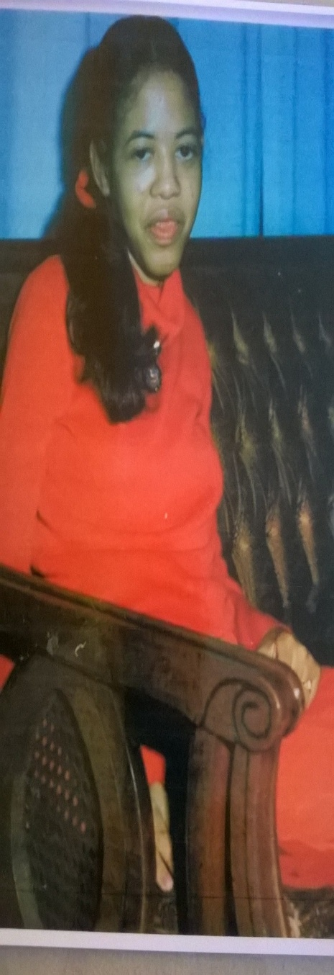
Yolanda Hardman was born on September 8, 1958 and passed away on May 22, 2015. Yolanda was the light in her families’ lives, and they remained dedicated to her until her passing. Since Yolanda lived at home with her mom, who was devoted to making sure all her needs were met, the state limited the resources available or offered to her.
Due to her mental and physical challenges and the limited resources available she did not have the chance to reach her fullest potential.
The Yolanda Hardman Scholarship Fund has been set up to be able to offer an individual who otherwise would not have the resources to participate in any meaningful activities while home for the summer.
The Smart Place Adult and Children Services is a 501(c) (3) organization that provides day support for developmentally and intellectually disabled individuals. These individuals participate in activities such as the Equestrian Program, Aquatics Program, Special Olympics, Meals on Wheels, and that’s just to name a few. They help to build fundamental life skills, gain a greater sense of self-worth, and a greater sense of community inclusion.
Please help us bring smiles to those faces that are too often forgotten.
All Donations are tax deductible. Our Tax Identification # is
01-0740608 Checks can be made payable to:
The Smart Place Adult & Children Services, Inc.,
FBO Yolanda Hardman

